“Clouds over Cloud Computing”

Afnan Pathan1  Ms. Swati Kabra2

*1Student at Department Of Computer Science and Engineering*

*Medi-Caps Institute of Technology and Management, Indore, India*

[afnanpathan@gmail.com](mailto:afnanpathan@gmail.com)

*2 Asst. Prof. at Department Of Computer Science and Engineering*

*Medi-Caps Institute of Technology and Management, Indore, India*

[swativkkabra@gmail.com](mailto:swativkkabra@gmail.com)

***Abstract*--** **The field of cloud computing is still in its infancy as far as implementation and usage, partly because it is heavily promoted by technology advancement and is so high resource dependent that researches in academic institutions have not had many opportunities to analyze and experiment with it. However, cloud computing arises from the IT technicians desire to add another layer of separation in processing information. Nevertheless, academia is developing in a significant presence, being able to address numerous issues. Data Security concerns are the biggest among these issues. In our report, we describe our experience and lessons learnt in checking the performance and security of the cloud using Aneka 2.0, a software platform for Cloud Computing. Security is one of the most important issues associated with the real world use to the cloud. Also, Cloud performance analysis and modeling are not easy tasks because of the complexity and large scale of the system. We aim to attain, through this report, a better understanding to the subject and to make it more reliable and secure to store confidential data through giving a solution to data security.**

***Keywords*-- Cloud Computing, Data Security, Cloud Performance, Aneka**

I. INTRODUCTION

*A. What is Cloud Computing*

Many people are confused as to exactly what cloud computing is, especially as the term can be used to mean almost anything. Roughly, it describes highly scalable computing resources provided as an external service via the internet on a pay-as-you-go basis. The cloud is simply a metaphor for the internet, based on the symbol used to represent the worldwide network in computer network diagrams.

Economically, the main appeal of cloud computing is that customers only use what they need, and only pay for what they actually use. Resources are available to be accessed from the cloud at any time, and from any location via the internet. There’s no need to worry about how things are being maintained behind the scenes – you simply purchase the IT service you require as you would any other utility. Because of this, cloud computing has also been called utility computing, or ‘IT on demand’.[6]

*B. Types of Clouds*

Public Cloud:

Public cloud describes the conventional meaning of cloud computing: scalable, dynamically provisioned, often virtualized resources available over the Internet from an off-site third- party provider, which divides up resources and bills its customers on a ‘utility’ basis.

Private Cloud:

Private cloud (aka ‘corporate’ or ‘internal’ cloud) is a term used to denote a proprietary computing architecture providing hosted services on private networks. This type of cloud computing is generally used by large companies, and allows their corporate network and data centre administrators to effectively become in-house ‘service providers’ catering to ‘customers’ within the corporation. However, it negates many of the benefits of cloud computing, as organizations still need to purchase, set up and manage their own clouds.

Hybrid Cloud:

It has been suggested that a hybrid cloud environment combining resources from both internal and external providers will become the most popular choice for enterprises. For example, a company could choose to use a public cloud service for general computing, but store its business-critical data within its own data centre.

*C. Services of Cloud (Refer Figure 1)*

Services provided by cloud are classified as[1]:

SaaS (Software as a Service)

Vendor supplies the hardware, infrastructure, the software product and interacts with user through a front-end portal.

PaaS (Platform as a Service)

PaaS is defined as set of software and product development tools hosted on the provider’s infrastructure.

IaaS (Infrastructure as a Service)

IaaS provides virtual server instances with unique IP addresses and blocks of storage on demand.

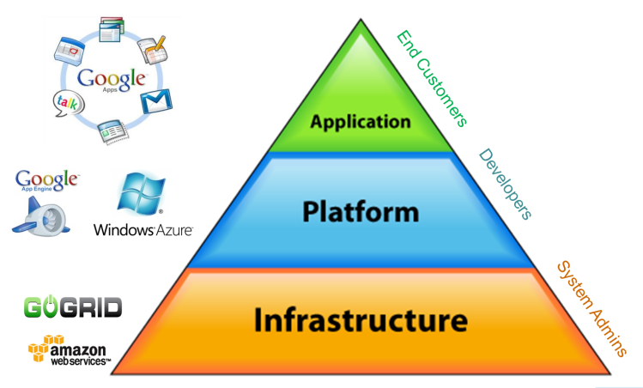

Fig. 1 Cloud Pyramid

In current scenario, sectors like banking and others are still using the traditional way (servers) and are not using cloud the reliability of cloud due to security and performance. The purpose of this paper is to find a way to make cloud more secure to use for the sectors other than IT by making a research in security and performance domain.

II. LITERATURE SURVEY

A paradigm shift to cloud computing will affect many different sub-categories in computer industry such as software companies, internet service providers (ISPs) and hardware manufacturers. While it is relatively easy to see how the main software and internet companies will be affected by such a shift, it is more difficult to predict how companies in the internet and hardware sectors will be affected.[2][3]

The implementation of cloud will aim at reduced cost, centralization of data, scalability, monitoring of performance, improvements for systems that are often only 10–20% utilized. In short the affects of shifting completely to the cloud will affect the entire industry and more.

*A. Tools*

Eucalyptus:

Eucalyptus[4] is a software platform for the implementation of private cloud computing on computer clusters. There is an open-core enterprise edition and an open-source edition. Currently, it exports a user-facing interface that is compatible with the Amazon EC2 and S3 services but the platform is modularized so that it can support a set of different interfaces simultaneously.

Microsoft Windows Azure : Microsoft Windows Azure Platform[7] is a Microsoft cloud computing platform used to build, host and scale web applications through Microsoft data centers. Azure is classified as platform as a service and forms part of Microsoft's cloud computing strategy, along with its software as a service offering, Microsoft Online Services.

Table 1. Comparison of various commercial offerings of Cloud

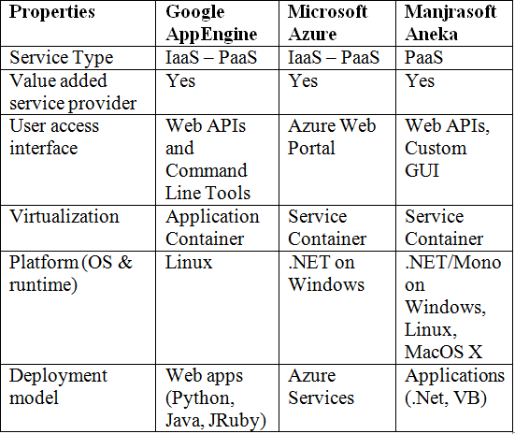

*B. Advantages of Cloud Computing*

* Minimized Capital expenditure
* Location and Device independence
* Utilization and efficiency improvement
* Very high Scalability
* High Computing power

*C. Application Areas of Cloud Computing*

The major trends in cloud usage are depicted in Figure 2[9].Some general applications are:

Hosted Desktops: A hosted desktop looks and behaves like a regular PC, but the software and data customers use are housed in remote, highly secure data centers, rather than on their own machines.

Hosted Telephony (VOIP): VOIP (Voice Over IP) is a means of carrying phone calls and services across digital internet networks. In terms of basic usage and functionality, VOIP is no different to traditional telephony, and a VOIP-enabled telephone works exactly like a 'normal' one, but it has distinct cost advantages.

Cloud Storage: Cloud storage is growing in popularity due to the benefits it provides, such as simple, CapEx-free costs, anywhere access and the removal of the burden of in-house maintenance and management.

Dynamic Servers: Dynamic servers are the next generation of server environment, replacing the conventional concept of the dedicated server. You can directly control the amount of processing power and space you use, meaning you don't have to pay for hardware you don't need.

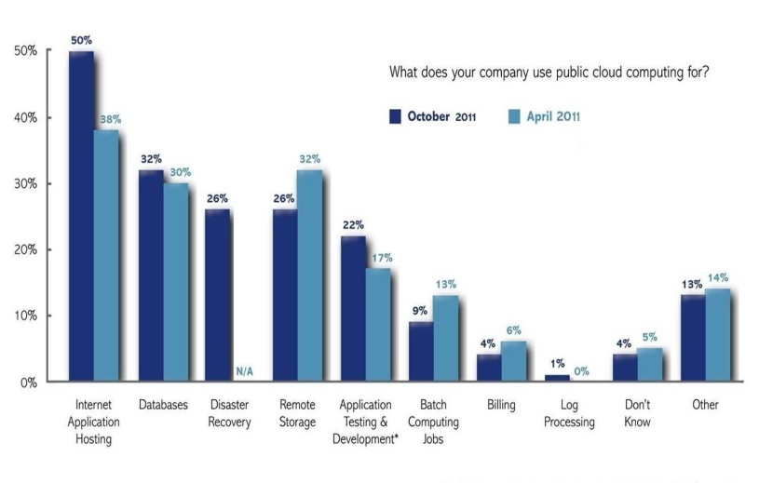

Fig. 2 Cloud Applications

*D.SWOT analysis*

Strength: Cloud computing offers organizations the ability to effectively use time distributed computing resources. Cloud computing leads to reduced infrastructure costs and energy savings as well reduced upgrades and maintenance costs. Economies of scale for datacenters cost savings can lead to a 5- to 7-time reduction in the total cost of computing. Cloud computing services allow an organization to control when, where, and how employees have access to the organization's computer systems, all managed over a simple web-based interface.

Weaknesses-issues that need to be resolved before cloud computing can be accepted as a viable choice.

1. Organizations will be justifiably wary of the loss of physical control of the data that is put on the cloud.

2. Providers have been unable to guarantee the location of a company's information on specified set of servers in a specified location.

Opportunities-One of the significant opportunities of cloud computing lies in its potential to help developing countries reap the benefits of information technology without the significant upfront investments that have stymied past efforts. Moving to the cloud will allow organizations to not only reduce their IT infrastructure, but, since it is much cheaper to transport computing services than energy, it will also represent a smarter use of energy.

Threats-One of the biggest threats to cloud computing is the possibility of backlash from entrenched incumbents. Another legitimate concern has centered on cloud providers going bankrupt, especially in a shrinking economy. Yet another concern is security[5][10] — in an ongoing survey conducted by the research firm IDC, almost 75 percent of IT executives and CIOs report that security is their primary concern, followed by performance and reliability.

International Organization for Standardization's (ISO) technical committee for information technology has just announced the formation of a new Subcommittee on Distributed Application Platforms and Services (DAPS) that includes working a Study Group for standardization of cloud computing.

*E. Information Security Policy*

It varies from data privacy, security to data ownership and audit. Security is a wide area of research in cloud computing. Cloud Computing has adopted various security services with standard contents, and rapid response to security attacks, thus a provider needs to be “battle ready”. Earlier Service Level Agreements (SLA) had gaps in security defenses which lead to uncovered liabilities for client. With multi-tenant and reusing nature it is not possible to delete data whenever client wishes, hence here an extra element of risk in terms of security and legal compliance for sensitive data is introduced. All these lead to optimal risk transfer effect of different breaches on security, forensics, and evidence gathering mechanism.

III. METHODOLOGY

*A. Aneka Tool*

Aneka[8] is a platform for deploying Clouds developing ap1plications on top of it. It provides a runtime environment and a se1t of APIs that allow developers to build .NET applications that leverage their computation on either public or private clouds. One of the key features of Aneka is the ability of supporting multiple programming models that are ways of expressing the execution logic of applications by using specific abstractions. This is accomplished by creating a customizable and extensible service oriented runtime environment represented by a collection of software containers connected together. By leveraging on these architecture advanced services including resource reservation, persistence, storage management, security, and performance monitoring have been implemented. On top of this infrastructure different programming models can be plugged to provide support for different scenarios as demonstrated by the engineering, life science, and industry applications.

*B. Aneka Daemon*

The Aneka Daemon is responsible for managing Aneka Containers that make up our cloud. This includes installing new Containers, starting, stopping and uninstalling Containers. Aneka Daemons provide the underlying management infrastructure for Aneka Clouds.

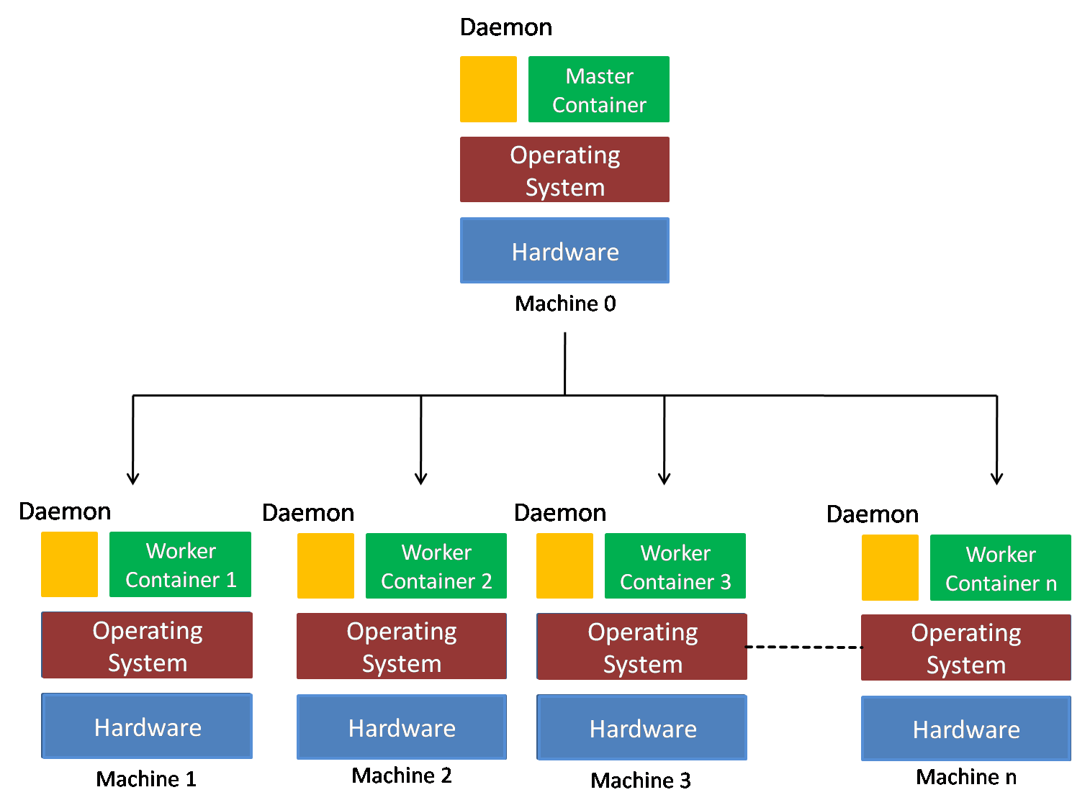

Fig. 3 Aneka Architecture

*B. Aneka Containers*

Once you have the Aneka Daemon running on all selected machines you are now ready to create an Aneka Cloud. As described earlier, an Aneka Cloud is composed of a *Master Container* and group of *Worker Containers*. All Workers are registered to the Master, which acts as a gateway to the Cloud. End-users submit their applications, composed of a number of jobs, to the Master which in turn schedules them to Workers.

To begin creating your cloud, you must first decide on the machine that will host the *Master Container*. Ideally, this must be a machine capable of processing requests from a number of clients while also managing a large number of Workers. The capability of this machine will of course depend on the size of your cloud and the expected usage.

*D. Proposed Solutions*

Multiple Encryption:

Multiple encryption is the process of encrypting an already encrypted message one or more times, either using the same or a different algorithm. The terms cascade encryption, cascade ciphering, multiple encryption, multiple ciphering, and superencipherment are used with the same meaning.

StegnoCrypt

Steganography and Cryptography are two popular ways of sending vital information in a secret way. One hides the existence of the message and the other distorts the message itself. In Steganography we have various techniques in different domains like spatial domain, frequency domain etc. to hide the message. It is very difficult to detect hidden message in frequency domain. In this technique a system can be developed in which Cryptography and Steganography are used as integrated part along with newly developed enhanced security module.

*E. Implemented Algorithm*

x:=character read from the file

n:=is the number by which character is shifted

t:=number of times to encrypt

//Encryption

for(int i=1;i<=t;i++) {

if (character is in alphabet)

E(x)=x+n mod 26

else if(character is a number)

E(x)=x+n mod 10

else if(special character)

E(x)=x

}

//Drecryption

for(int i=1;i<=t;i++)

{

if (character is in alphabet)

D(x)=x-n mod 26

else if(character is a number)

D(x)=x-n mod 10

else if(special character)

D(x)=x

}

IV. EXPERIMENTATION

*A. Architecture*

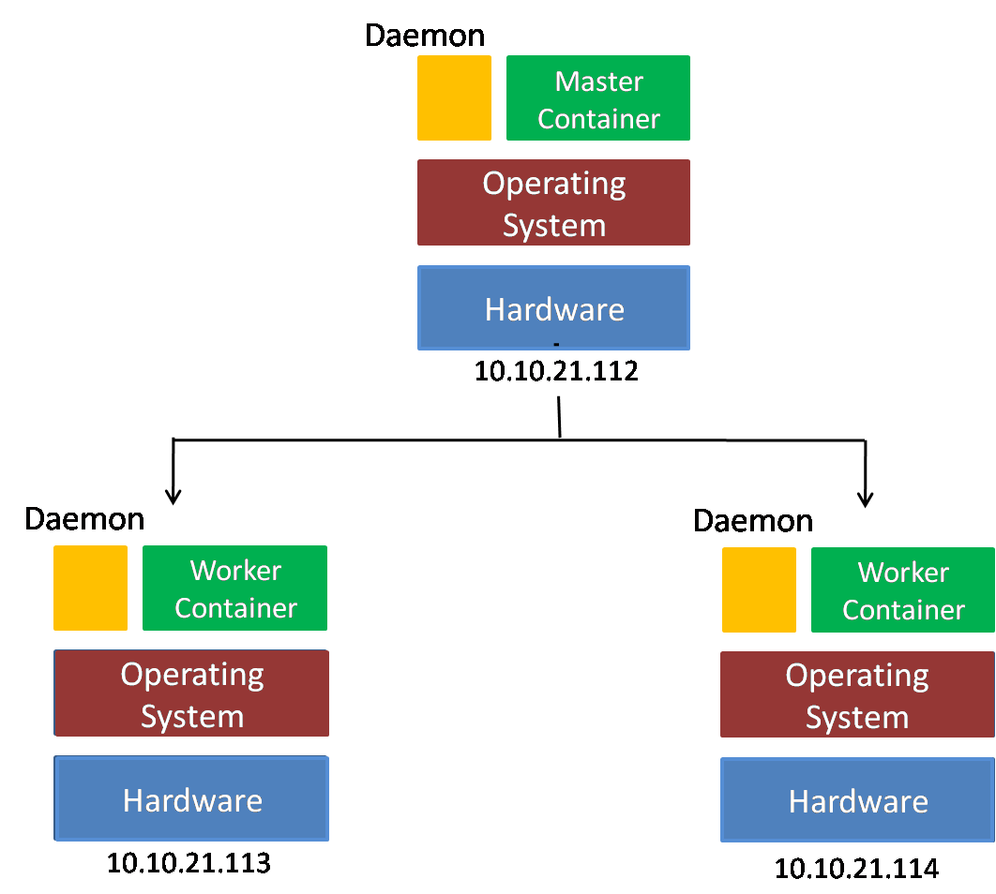

Fig. 4 Implemented Aneka Architecture

*B. System Configuration*

Hardware Specification

1. 3 Computers with following configuration:
   1. 1G RAM
   2. 40 MB disk
   3. LAN connectivity

Software Specification

1. Aneka 2.0
2. . Net Framework 2.5+

*C. Setup*

Aneka cloud in our scenario was established on three machines. Machine 10.10.21.112 has master container installed on it. Machines 10.10.21.113 and 10.10.21.114 have worker container installed on them. Workers are registered to the Master, which and end-users submit their applications, and composed of a number of jobs, to the Master which in turn schedules them to Workers. The setup was completed in two modules with daemon configuration in former phase and container installation in the latter.

V. RESULTS

The performance results obtained in different cases using Aneka are summed below in different cases with their tables and respective graphs.

Case I:

No of CPU/Nodes: 6/3

Max. Available Power: 12 Ghz

Max memory available: 9.6 GB

Max Storage: 894.27 GB

Table 2. Dataset Obtained After Case I

|  |  |  |
| --- | --- | --- |
|  | **Power Available (%)** | **Power Usage (%)** |
| 1 Application | 85.7 | 14.3 |
| 2 Applications | 80.3 | 19.7 |
| 3 Applications | 74 | 26 |

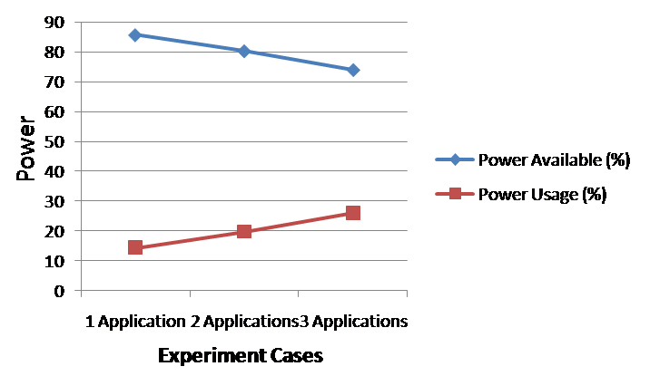

Fig. 5. Graph for Case I

Case II:

No of CPU/Nodes: 4/2

Max. Available Power: 8 Ghz

Max memory available: 6.4 GB

Max Storage: 596.18 GB

Table 3. Dataset Obtained After Case II

|  |  |  |
| --- | --- | --- |
|  | **Power Available (%)** | **Power Usage (%)** |
| 1 Application | 83.3 | 16.7 |
| 2 Applications | 79.6 | 20.4 |
| 3 Applications | 71.4 | 28.6 |

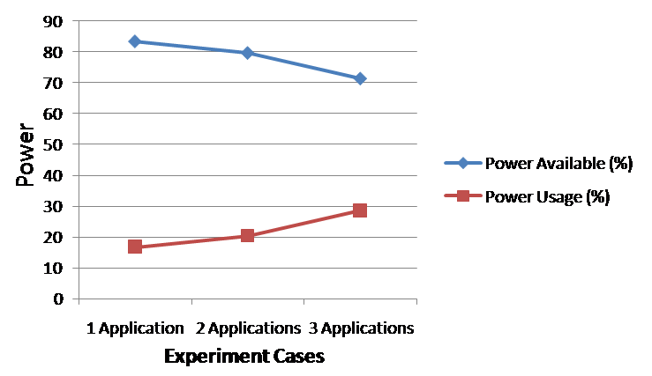

Fig. 6. Graph for Case II

Case III:

No of CPU/Nodes: 2/1

Max. Available Power: 4 Ghz

Max memory available: 3.2 GB

Max Storage: 298 GB

Table 4. Dataset Obtained After Case III

|  |  |  |
| --- | --- | --- |
|  | **Power Available (%)** | **Power Usage (%)** |
| 1 Application | 82.2 | 17.8 |
| 2 Applications | 79.3 | 20.7 |
| 3 Applications | 70.5 | 29.5 |

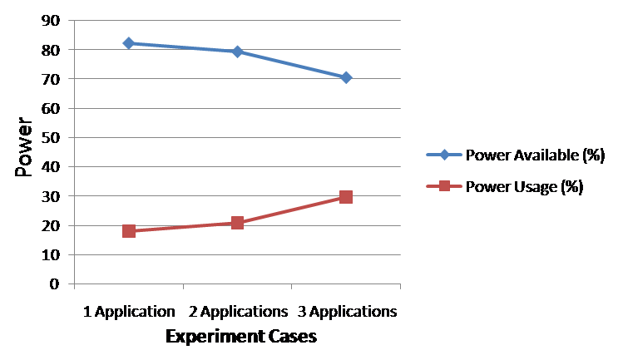

Fig. 7. Graph for Case III

VI. CONCLUSION

As the development of cloud computing, security issue has become a top priority. This paper presents the cloud computing technology, application area, environment with the security issues and performance through analyzing a cloud computing framework-Aneka. We found that as the number of applications is increasing maximum available power is degrading and there is a noticeable variation in power with change in the cloud resource configuration. Finally we conclude a multiple encryption Ceaser cipher algorithm for data security.

*A. Future Work*

We have implemented the multiple encryption solution on Ceaser Cipher only. Thus a wide scope lies for further future work through this paper. StegnoCrypt can be implemented which upgrades data security to a higher level.

ACKNOWLEDGEMENT

Expressing gratitude is a difficult task and words often fall short of reflecting one’s feelings It is my proud privilege, however to do so and I undertake this task with utmost sincerity. I am grateful to Ms. Swati Kabra, for her invaluable guidance, significant suggestions and support for accomplishing this work.

REFERENCES

[1] Voorsluys, William; Broberg, James; Buyya, Rajkumar, "Introduction to Cloud Computing", New York, USA: Wiley Press. pp. 1–44. ISBN 978-0470887998, 2011.

[2]Toby Velte, “*Cloud Computing: A practical Approch*”

[3] Barrie Sosinsky, “*Cloud Computing Bible*”, February 2011

[4] Daniel Nurmi, "*The Eucalyptus Open-Source Cloud-Computing System*." CCGRID '09 Proceedings of the 9th IEEE/ACM International Symposium on Cluster Computing and the Grid, 2009.

[5] Winkler, Vic “Securing the Cloud: Cloud Computer Security Techniques and Tactics”. Waltham, MA USA: Syngress. pp. 187, 189. ISBN 978-1-59749-592-9, 2011.

[6] D Kyriazis, A Menychtas, G Kousiouris, K Oberle, T Voith, M Boniface, E Oliveros, T Cucinotta, S Berger, “A Real-time Service Oriented Infrastructure”, International Conference on Real-Time and Embedded Systems (RTES 2010), Singapore, November 2010

[7] "Windows Azure Platform". Microsoft. Retrieved 15 January 2011.

[8] ChristianVecchiola, Xingchen CHU “Aneka: A Software Platform for

.NET-based Cloud Computing”, www.manjrasoft.com/Case% 20Study_ADRIN_Dept_of_Space.pdf

[9] IDC Enterprise Survey, 2010

[10] Cloud Security Alliance, Security Guidance for Critical Areas of Focus in cloud computing Cloud Security Alliance, 2009